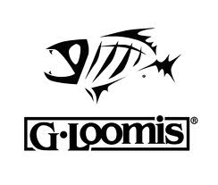
FREE ENTRY G-LOOMIS OWNER’S TOURNAMENT
September 14, 2013

1ST Place: 2 GLX Rods and 2 Technical T-Shirt
Retail $ 1060
2nd Place: 2 MossyBack Rods and 2 Technical T-Shirt
Retail $ 740
3rd Place: 2 GL₂ Rods and 2 G Loomis Hats
Retail: $ 470
4th Place: 2 G Loomis Tackle Bags and 2 G Loomis Hats
Retail: $ 210
5th Place: 4 G Loomis Hats
Retail: $ 100

GUARANTEED PRIZES!!!!!!!!

***Big Fish Optional Pot $25 Per Team***
100% Payback (1st 75% & 2nd 25%)

